
Blockley Parish Council
Minutes
Thursday 15th January 2026
Little Village Hall, Blockley, 7pm

Meeting opened: 19.00hrs
Present: Cllr & Chair Jon Bryan (JB), County Councillor Thomas Bradley (TB), Cllr Chris Leach (CL), Cllr Ellie Thorneycroft (ET),
Cllr Jez John (JJ), Cllr Andy Turton (AT), Cllr Chris Palengat (CP), Cllr Ian Cook (IC), Cllr Zoey Maull (ZM)
Apologies: Cllr & Vice Chair & District Cllr Clare Turner (CT)
Members of Public: None
Minutes: Charlotte Bullock BPC Admin. Assistant (CB)
- Welcome and apologies for absence.
- Declarations of Interest and Dispensations for items on the agenda - JB & ET have school age children who could benefit from Youth Club. IC & CP on St Georges Hall committee. JB contracts for Goodings Group. ET has a neighbour with planning permission for a tree.
- Public Participation - None.
- Approval of the minutes of the Parish Council Meeting of 20.11.25. Agreed by majority. JJ abstained as was not present at November meeting. AT arrived after this item.
  - Matters arising – see appendix 1
- County and District Councillors’ updates – appendix 2&3
AT arrived 7.35pm
- Finance: Cllr Bryan
  - Resolved to approve Finance Report for 14.11.25 – 09.01.26 including bank reconciliation for November & December 2025 & detailing all accounts held by the council as circulated and shared prior to meeting. Unanimous
  - Resolved to approve Transactions for period 14.11.25 - 09.01.26 as shared prior to meeting. Unanimous.
  - Resolved to approve Reserves re-allocation, as shared prior to meeting. Unanimous.
  - Resolved to approve use of allocated Reserves up to £5k contribution towards St George’s Terrace handrail repair & replacement (Highways budget), ACTION: JB check with TB for timeline, £2k for Traffic Flow Surveys and White Entrance Gates cost tbc. Once authorisation received from GCC Highways. ACTION: TB offered to follow up. Unanimous.
  - Councillors considered Grant Application from Toddler Group for £497, as shared prior to meeting. Resolved to approve. Unanimous. Cllrs discussed the limitations of current storage facilitates and if further assistance can be given. ACTION: CB to advise Toddlers and ask if assistance needed to optimise current storage solutions.
  - Resolved to approve appointment of independent and competent internal Auditor, Mrs I Litton BEM, details as shared prior to meeting. Unanimous. ACTION: NH to advise & book.
  - To ratify overtime payment to MO for 46.4 hours from Personnel Reserves. Agreed by majority. JJ abstained.
- Youth & Recreation: Cllr Leach
  - Councillors received update on Youth Club. March is next scheduled meeting with provider. Continuing to review attendance figures. ACTION: CB to continue to circulate Infants poster on website & social media.
  - Councillors received an update on Brownies: Cllr Maull.
- Community: Cllr Turner – JB in CT absence.
  - Received an update on plans for working party for parish footpaths creation. Look to increase verge sizes for parish paths among other areas requiring tidying and maintenance. ACTION: JB to check availability with CL & report to Cllrs, review verge options with Thomas Fox.
  - Reviewed Aston Magna resident issue re road safety (c/f Cllr Bradley) as shared prior to meeting – TB has asked Highways for what additional visibility and signage can be done. ACTION: TB to update via email, resident on cc.
  - Considered re-surfacing of road outside Blockley Shop & Café to discuss with County Cllr Bradley – supported by majority. TB to discuss with Highways. ACTION: TB to report back.
- Planning: Cllr Turton
  - Reviewed current planning applications as shared prior to meeting. No recommended actions.
  - Received NPS report update. ACTION: AT – to book in-person sessions to share the results with residents, to share his availability with the council for additional attendees. CB can book hall dates once advised. JB - Investigating Planning Consultant options.
  - Resolved to approve adding Cllr Cook to NPS working group. Unanimous.

- Website & IT: Cllr John
  - Received an update on progress of new website. ACTION: JJ to coordinate group session with councillors to populate website copy on Thursday before end of February.
- Cllrs received an update on various matters: Cllr Cook
  - Cllrs received an update on GCC on-street EV charging around the parish, as shared prior to meeting. TB advised GCC not considering Blockley until next FY.
- Received a St George’s Hall Management Committee update: Cllr Turner – IC in CT absence. PPM visit conducted by Gooding Group, for SGH committee review 29th Jan. Considering potential enhancements to drive revenue including reordering options to review with stakeholders and report back.
- Clerk’s Highlights – as shared prior to meeting. ACTION: NH Add approval of model publication scheme to February agenda.
- Received Parish Councillors’ reports on matters not on the agenda. ACTION: JB to contact Highways re: blind summit on road to Northwick Park / builders vans. CP to investigate trailer options for MO mower. ZM to investigate bleed control kits, estimated £102 each for consideration to add to Defibrillators, JB queried shelf life to inform costs. NH to add to February agenda. NH add Personnel update to the February agenda.

Meeting closed: 20.57
Date of next meeting: Thursday 19th February 2026, Paxford Village Hall.
Bank: The bank was last reconciled to the 31st December
Current Account Balance: £39,964.08
Instant Access Account Balance: £158,736.75
Total: £198,700.83. Adjusted Bank Balance considering unpresented payments and receipts Total: £195,700.83
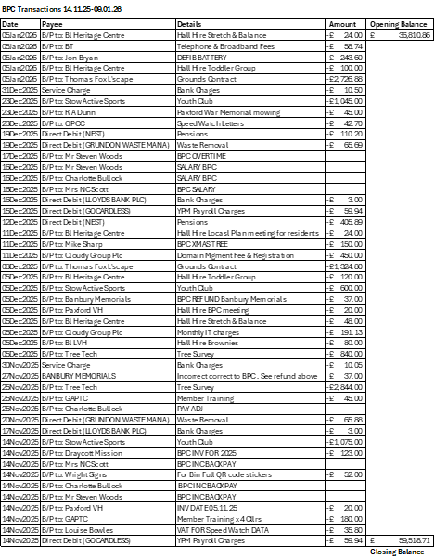
Of note
Income:
- Banbury Memorials £37 (mistake)
Expenditure:
- £37 credit 27.11.25 to Banbury Memorials incorrectly sent & refunded by us on 02.12.25
- Credit interest on Deposit Account £870.00 on 31.12.25
- Other items of note: Steve Woods payment of £426.76 overtime as per agenda item 6.
- Tree Tech Survey Works £2,844.00 & £840 (Reserves)
- £450 Domain Mgment Fee & Registration Cloudy IT
- Back Pay corrections as identified from Payroll
- Blockley Christmas Tree £150
- New Defib Battery £243.60
Note also 4.8% price increase received from Grundon effective 1st Jan 2026
Unity Trust fee adjustment. Of note Monthly fee for account increases £6 to £7, BACS payments increase from1 4p to 15p per transaction.
Notes on Agenda items:
15.1.26.6.3 – Reserves re-allocation
SGH reserve fund renamed to account for broader community infrastructure projects. Consider bolstering funds here and in professional fees.
To discuss/update in meeting for approval.
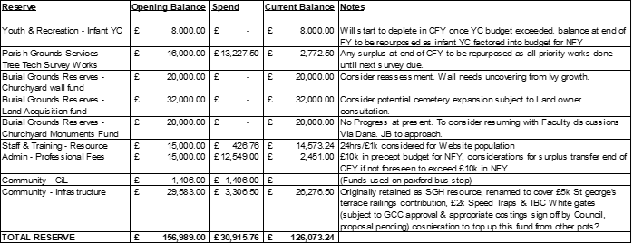

15.1.26.6.4 – Reserves allocation for GCC St George’s terrace railing contribution of £5k, Speed trap Surveys of £2k
15.1.26.6.5 – Blockley Toddler Group Grant application - £497, play equipment & lockable outdoor storage. Consideration to discuss limitations of current storage facilitates and if further assistance can be given. Would leave balance of £1,166 for rest of Financial year (totalling £4,834 awarded).
15.1.26.6.6 – Independent & competent Internal Auditor appointment - Mrs I Litton BEM (continuation)
15.1.26.6.7 – Overtime in lieu of Annual leave taken payment. 46.4 hrs, £580 gross. Personnel measures to be implemented to prevent further need.

Budget Updates
Outwith of reserves expenditure:

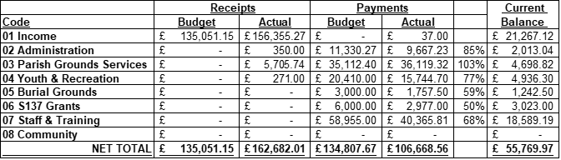

Parish grounds services exceed on sundry expenses for additional maintenance and repairs supplies requirement (consideration for next year where budget is unchanged) & unbudgeted defib supplies, latter is corrected in budget for NFY
Youth and recreation exceed on Parish events which is corrected in budget for NFY.
Review supplementary finance reports for month for detailed cost centre updates including all payments by cost centre.
Inclusive of Reserves expenditure
Note: Reserves expenditure was not budgeted which reflects across totals.
Key influencers are professional fees, tree works and CIL for Paxford bus stop.
New scribe set up allows us to report reserves expenditure without removing from deposit account to preserve interest accrual.
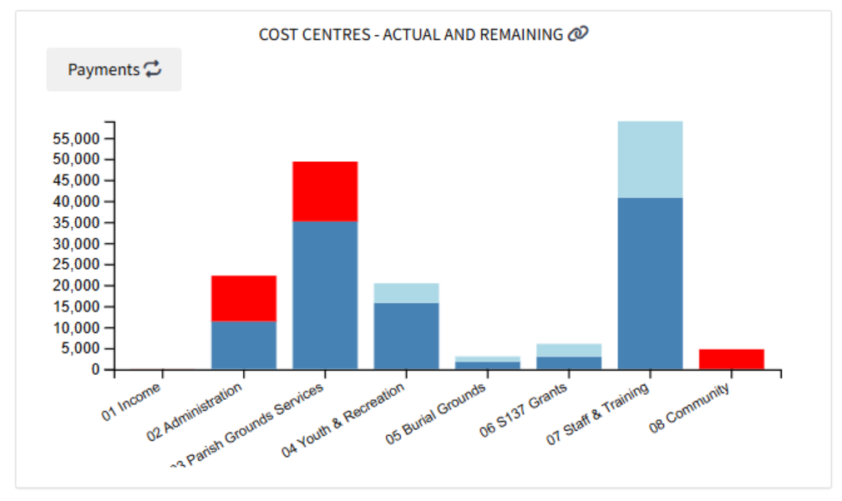

Net Position including reserves opening balances and expenditure (not budgeted)

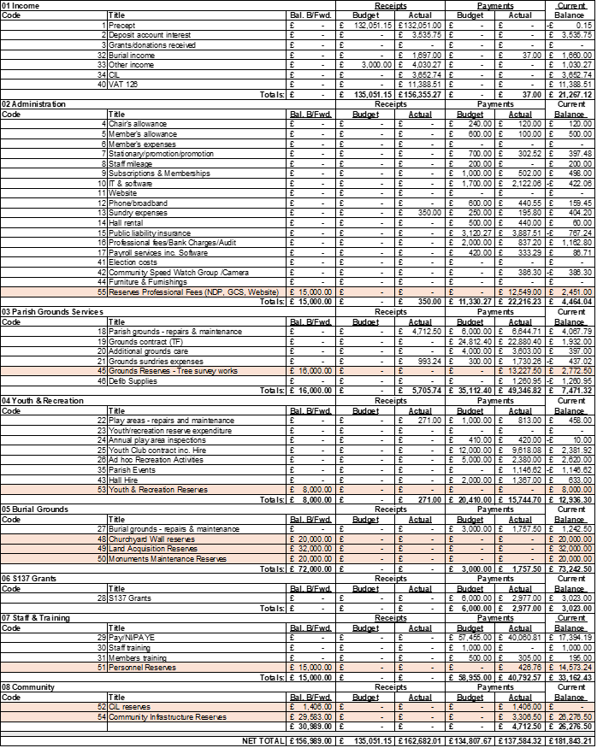

Signed Chair: __________________________ Date: __________________________

