Village halls in Blockley Parish
We’re lucky to benefit from five excellent village halls located across the parish. All are available to hire for
events like business meetings, performances and other
special interest groups at competitive rates. You can find more details about facilities, seating capacity and more below.
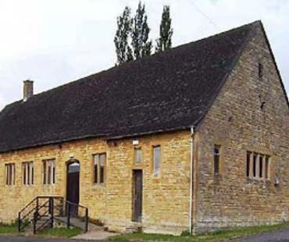

St George’s Hall
- Seats approx 165
- Theatre stage
- AV, sound & lighting rig
- Full premises licence
- Kitchen and catering facilities
- 60 parking spaces
- WC
- Wheelchair accessible
Booking enquiries to Hall Manager info@stgeorgeshallblockley.org.uk
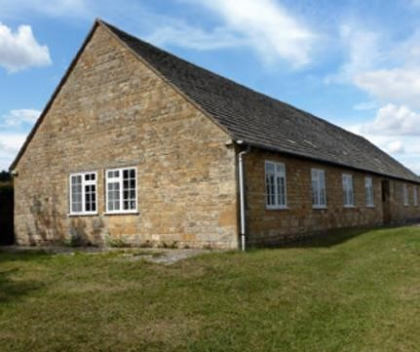

Jubilee Hall
- Seats approx 80
- 60 parking spaces
- Kitchenette
- WC
- Projector screen
- Central heating

Booking enquiries to Hilary Sutton on
01386 700914 or suttons46@outlook.com
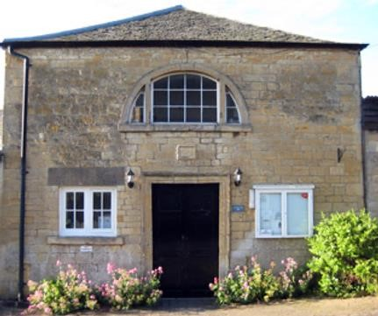

Little Village Hall
- Seats approx 35
- Well equipped kitchen
- Gallery
- Recently refurbished
- SmartScreen TV
- Gigaclear Business Ultra broadband
- Fully accessible WC
- Wheelchair accessible

Booking enquiries to 01386 700880, email info.blvh@gmail.com or visit www.blockleylittlevillagehall.org
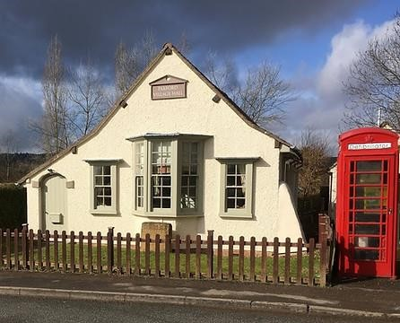

Paxford Village Hall
- Seats 56 maximum
- Well equipped kitchen
- Disabled WC
- Recently refurbished
- Wheelchair accessible
- Adjacent on-street parking

Booking enquiries to 01386 593090 Emailstephenjgoodfellow@yahoo.co.uk or visit www.paxford.org.uk
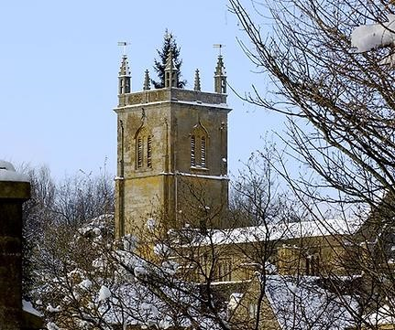

Draycott Mission Hall
- Seats approx 35
- Kitchenette
- WC
- Adjacent on-street parking
- Wheelchair accessible

Booking enquiries to Kim McQuail on
01386 700660 or info@draycott-mission.org

